HYBRID RATIO OPTION FOR HYBRID FACILITY ACCREDITATION

Background:
The SAWG approved the utilization of the ELCC method for wind, solar, and storage resource accreditation and has developed and approved the study process for each in a standalone configuration. The following twelve (12) separate analyses are anticipated to be required for standalone accreditation, for each summer and winter season:

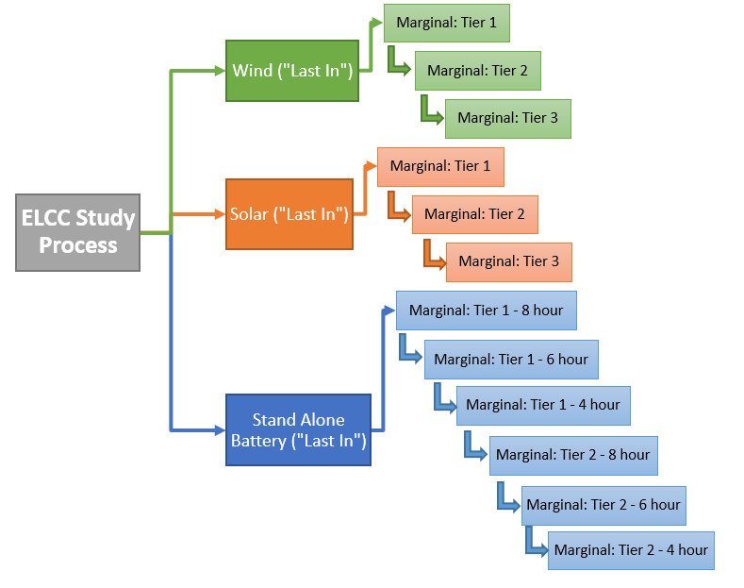
Study analysis method for reference: “Last in” vs “First in”:
The Wind, Solar, and standalone ESR ELCC studies use a “last in” approach where the system portfolio is considered in both the base case and the change case. For example, the base case for solar would include the system portfolio with wind and storage, and the base case for wind would include the system portfolio with solar and storage. The change case would be the addition of the class to be analyzed. For purposes of this discussion, a class is identified as a specific fuel type (wind, solar, storage). Within each class, a marginal tier process is used to analyze the incremental amounts of each additional tier within a class.

An alternative study process is a “first in” approach where the base case does not consider the effects of the other resource classes (wind, solar, storage). As the installed penetration of wind and solar resources increase, the “first in” approach has the potential to over accredit due to the fact that resources such as wind and solar provide less % of value to the net load as the penetration of these resources increase. The potential for over accreditation is particularly true for small resource classes with low penetration. Alternatively, as the penetration of wind and solar resources increase, causing the hourly profile of the net peak to shift, the “last in” approach may over accredit the value of energy storage.

Integrated Hybrid vs. Co-located Hybrid: FERC Order AD20-9 states that, “(1) co-located hybrid resources, generally referring to sets of resources that are modeled and dispatched as two (or more) separate resources that usually share a single point of interconnection; and (2) integrated hybrid resources (also referred to as co-controlled or integrated control hybrid resources), generally referring to sets of resources that usually share a single point of interconnection, and are modeled and dispatched as a single integrated resource.” The SAWG will need to consider refinement of these definitions for capacity purposes, however this proposal is intended to address the accreditation of Integrated Hybrid facilities.

Integrated Hybrid Considerations:
Integrate Hybrid facilities introduce an added layer of complexity, as they may consist of any combination of battery resources with varying ratios of storage to wind or solar capacity, as well as other technical differences such as variations grid charging ability, DC:AC inverter ratios, and inverter limitations.

Some SAWG Members voiced concerns that could have the potential to over accredit hybrid facilities:
- Generator Interconnection Limitations
- Ability to charge from the grid
- Charging impact from the Investment Tax Credit (ITC)
- Net Component Metering: SAWG will need to determine how the resources utilized for charging of a storage device will be accredited. The default assumption in this proposal is that the ELCC wind and solar studies will utilized the hourly net (net of charging) output for accreditation purposes. This would be the output that reaches the transmission system and is useful to meet the SPP load. This net output would need to be sufficiently supported with the appropriate meter data. If gross output were to be used, then the charging load would have to be incorporated in an LRE’s load requirement to avoid a gap in resources adequacy.

With the multiple configuration possibilities, the SAWG worked to achieve the following balance of objectives:
- Consider significant issues or concerns for accrediting hybrid facilities
- Minimize potential to over or under accredit resources
- Balance workload and time with the accuracy of results
- As needed, determine the need for additional analysis and provide staff with clear direction

Generator Interconnection (GI) Limitations: There is consensus that the accreditation of a hybrid facility should be limited to the amount of Interconnection Service as specified in the Generator Interconnection Agreement (GIA).
Ability to charge from the grid: There is some disagreement as to whether the ability to charge from the grid and the investment tax credit should be considered when determining the accreditation of a hybrid facility.

The study performed by Astrape on SPP’s system indicated that as higher penetrations of battery and storage are attained, charging limitations could significantly decrease the accreditation that an Integrated Hybrid facility should receive. It is not clear, however, if the ITC will function as a hard charging limitation, because generator operators will make decisions based on market pricing.
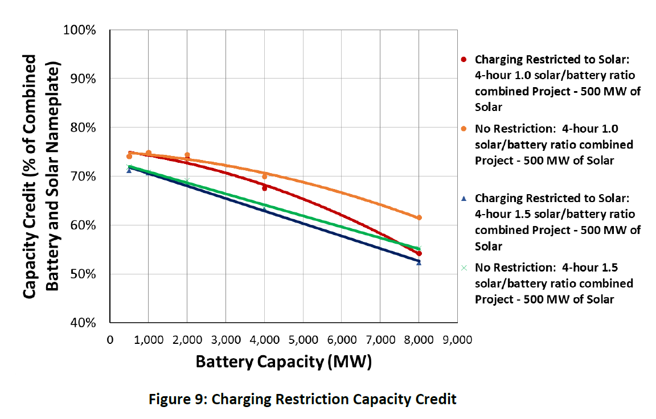
New Proposed Integrated Hybrid Ratio Option:
Due to the numerous variations of hybrid facility configurations, one option for Integrated Hybrid accreditation is to simply study each components of the hybrid individually, add them together, and then cap the accreditation according to physical limitations (i.e. GI, or Invertor limitation). This Sum of the Parts option, however, does not consider that Integrated Hybrids may operate differently than if they were not integrated, and that this may warrant a different accreditation than method the Sum of the Parts. Therefore, a proposed alternative is the Hybrid Ratio option.

The Hybrid Ratio option would add one (two additional studies if SAWG feels wind and solar should be separated) additional ELCC study every year for all Integrated Hybrid facilities, as well as studying each Integrated Hybrid component separately in the appropriate standalone ELCC study from other ELCC approved policies shown in the graphic at the beginning of these comments above (wind, solar, storage).
- Each component (wind, solar, storage, etc.) of the Integrated Hybrid facility will be analyzed and preliminarily accredited in the appropriate stand-alone ELCC study. For example, wind in a wind ELCC, solar in a solar ELCC, storage in a solar ELCC. The same criteria of firm transmission and % of load will determine the specific tier the component will be placed in.
  - The SAWG will need to determine how the firm transmission might be allocated between the components of a hybrid facility if firm transmission is not acquired for the entirety of the nameplate output of the hybrid facility. One possible option is to allow the LRE to determine the firm transmission ratio between the components.
- All Integrated Hybrid facilities will then also be analyzed in an Integrated Hybrid Only ELCC Study containing. The Integrated Hybrid Only ELCC study will not be broken into separate tiers.
  - If the Integrated Hybrid Only study determines a different amount than the sum of the Integrated Hybrid components in the stand-alone studies, then Integrated Hybrid facilities will be accredited based upon a ratio of their stand-alone component accreditation to the total MW’s available in the Integrated Hybrid Only study. This is similar to the methodology of allocation for wind and solar ELCC based upon the interaction of each resource with load.
  - This may result in higher or lower accreditation than the Sum of the Parts option and individual Integrated Hybrid facilities may also receive higher or lower accreditation than other Integrate Hybrid facilities.
  - For example:
    - Integrated Hybrid Only study has 5 Integrated Hybrid facilities and results in a total accreditation of 1000 MW
    - The sum of the standalone Integrated Hybrid component accreditation results in a total of 1030 MW for:
      - Hybrid Facility A Stand-Alone (i.e. solar+storage): 205
      - Hybrid Facility B Stand-Alone: 195
      - Hybrid Facility C Stand-Alone: 210
      - Hybrid Facility D Stand-Alone: 250
      - Hybrid Facility E Stand-Alone (i.e. solar+wind): 170
    - Final Hybrid Accreditation would then be as follows:
      - Hybrid Facility A (i.e. solar+storage): (205/1030)*1000 = 199
      - Hybrid Facility B: (195/1030)*1000= 189
      - Hybrid Facility C: (210/1030)*1000= 204
      - Hybrid Facility D: (250/1030)*1000= 243
      - Hybrid Facility E (i.e. solar+wind): (170/1030)*1000= 165

- In all cases, Integrated Hybrid facilities will not receive accreditation which exceeds the facilities Generation Interconnection or physical limits.
- The Integrated Hybrid Only ELCC study would be performed similar to the standalone ELCC studies as a “last in” approach.
This Integrated Hybrid Ratio Option:
- Does require staff time in addition to the Sum of the Parts Option due to the addition Integrated Hybrid Only study, however, it does not add a substantial amount of staff time because:
  - Avoids the complexity of determining multiple hybrid ELCC classifications. For example, wind+storage/high storage ratio, solar+ storage/high storage ratio, wind+ storage/high storage ratio, solar+ storage/high storage ratio, etc.
  - Avoids the complexity of determining the order in which multiple hybrid ELCC classifications should be analyzed. For example, does the wind+storage class come before solar+storage or are each studied as “last in” or each studied as “first in.” Because of the interrelationship between classes, this has the potential to under or over accredit depending on the ratio of storage and if the hybrid is an antagonist (more decreases the accreditation of the class as a whole), or not.
- Utilizes SPP’s current tiered accreditation processes
  - Firm transmission can still be used to determine the tier.
  - The limits between tier 1 and 2 for wind and solar can still be used and Integrated Hybrid facilities will be placed on an equal footing.
  - Eliminates the concern that a Integrated Hybrid facility could receive less or more accreditation just because it was studied as a hybrid facility as compared to studied as standalone resources. This is an incremental benefit to the Sum of the Parts Option.
- Indirectly considers the differences in DC:AC invertor ratio’s between projects because of the allocation method with wind and solar. Integrated Hybrid resources with more beneficial DC:AC ratio’s could produce solar profiles that are better matched with load profiles, and would therefore have a higher accreditation.
- Indirectly considers the Integrated Hybrid ratios of solar PV overbuild and ability to capture clipped energy due to overbuild because of the allocation method with wind and solar Integrated Hybrid resources with more beneficial solar profile would be better matched with load profiles and would therefore have a higher accreditation.
- Will account for the impact of grid charging ability.
  - Solar and wind output shapes will account for net storage charging in the standalone solar and wind ELCC studies. This means the solar or wind output shape will be decremented at the times when the energy storage resource is being charged by the solar or wind resource.
  - For the hybrid ELCC study, charging times will be added back to the solar or wind shape.

