

**Effective Load Carrying Capability Energy Storage Study Scope**

SPP Resource Adequacy

# Revision History

| Date or version number | Author | Change Description | Comments |
| --- | --- | --- | --- |
| 4/15/2021 | SPP Staff | Initial Draft |  |
|  |  |  |  |
|  |  |  |  |
|  |  |  |  |

Contents

Revision History i

Background and Overview 1

Objective 2

Study Timeline 3

Input Data and Assumptions 4

Software 4

Base Model and Assumptions 4

Transmission Modeling 4

Historical Outages 4

Energy Storage Resource Modeling 4

Study Years and Hourly Historical Shapes 5

Seasonal Considerations 5

Generation Portfolio 5

Study Scenarios 5

Additional Study Assumptions 7

Study Process 8

Tier Determination 8

ELCC Analysis 8

Allocation Process 9

ELCC Capacity Allocation 10

Reporting and Deliverables 11

# Background and Overview

Effective Load Carrying Capability (ELCC) is defined as the amount of incremental load a resource, such as a battery, can dependably, and reliably serve, while also considering the probabilistic factors such as random forced outages, historical weather patterns, and load forecast variability.

Using ELCC practices, a facility’s accreditation is the probabilistic, fractional measure of the facility’s nameplate rating that can be relied on to serve load when planning for resource adequacy. Underestimating the contribution of variable generation resources, such as wind or solar, to help meet forecast system peaks can result in the acquisition of unnecessary generation capacity. Overestimating the ability of such variable generation resources to help serve forecast system peaks can result in increased risks of unserved load, which degrades system reliability.

ELCC is typically measured as the amount by which a system’s load can increase when the resource(s) is added to the system while maintaining a system reliability metric. This ELCC study will utilize the reliability metric of 1 day in 10 years (or 0.1 day/year), as also used in SPP’s Loss of Load Expectation (LOLE) Study.

The ELCC process will consist of two phases applied to both winter and summer seasons for all eight (8) hour, six (6) hour, and four (4) hour energy storage resources. The first phase will be to determine an SPP system with no energy storage resources modeled to serve as the “base case” maintaining a reliability threshold of 0.1 LOLE. The second phase will add energy storage resources to the system which will improve the overall system reliability. Once energy storage resources have been applied to the model, the peak load of the system will be scaled until the reliability of the system returns to 0.1LOLE. The ratio of the capacity of energy storage added to the system to the amount the peak load that was increased gives the capacity credit of the energy storage resources.

# Objective

The intent of the ELCC Energy Storage Study is to determine the accredited capacity of energy storage resources in the SPP footprint. The amount of accredited capacity for energy storage resources will be a percentage of their nameplate capacities and will decrease as the penetration increases across the Balancing Authority Area (BAA).

# Study Timeline

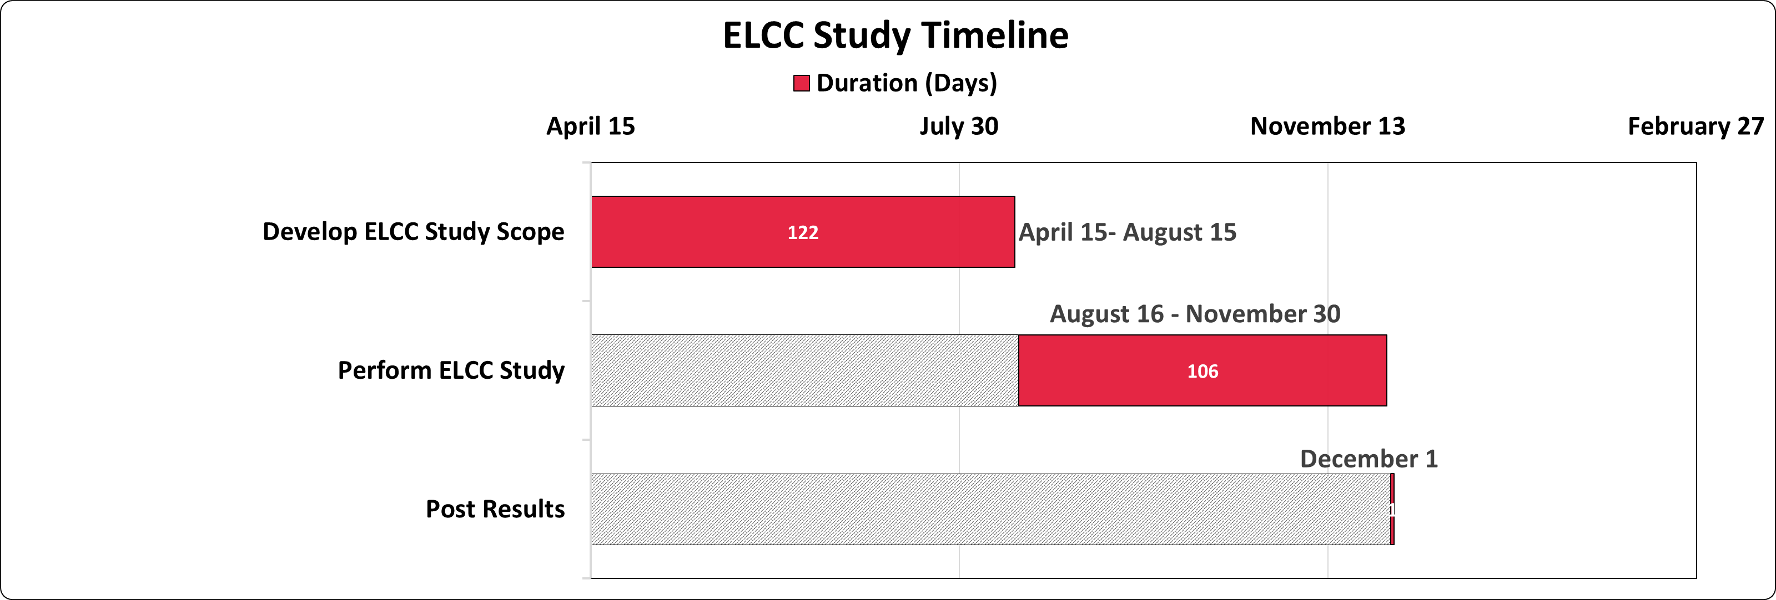

1. Develop ELCC study scope
2. Perform ELCC Study (Progress updates to the SAWG periodically)
3. Post Results

# Input Data and Assumptions

## Software

The ELCC Study will utilize the Strategic Energy Risk Valuation Model (SERVM) software from Astrapé Consulting, as what is also used for SPP’s Loss of Load Expectation (LOLE) Study. SERVM is a multi-area reliability and economic simulation tool that allows users to evaluate resource adequacy not only based on physical reliability metrics, such as the one day in ten years threshold, but also to assess the economics of such resource adequacy standards. SERVM combines the economic dispatch characteristics of production cost models with the granularity and probabilistic simulation capabilities of multi-area reliability models.

## Base Model and Assumptions

The assumptions and model used in the 2021 Loss of Load Expectation (LOLE) Study will serve as the basis for the ELCC analysis. The change in assumptions used in the ELCC analysis that differ from the 2021 LOLE study are listed in detail below.

## Transmission Modeling

Transmission limitations between the LOLE zones will not be modeled and the accreditation of energy storage resources will not reflect the restriction of transmission limitations.

## Energy Storage Resource Modeling

Energy storage resources will be modeled utilizing the following unit specific variables:

* Capmax – the maximum capacity the ESR outputs on the system in one (1) hour.
* Pndprice – the price at which the storage resource will be dispatched. The price modeled will reflect dispatch after all other unit types but before Demand Response units.
* Pndcap – the overall maximum capacity of the ESR.
* Charge_cap_max – the maximum capacity the ESR can charge in one (1) hour.
* Capmin – the minimum capacity of the ESR (assumed to be 0MW).
* Cyceff – the cycle efficiency of the ESR, assumed to be 90%.[1]

## Study Years and Hourly Historical Shapes

The hourly load submissions from LREs will be used in the model simulations. The 2021 LOLE Study will serve as the basis for the 2012-2020 historical years.

## Seasonal Considerations

Summer and winter seasons will be analyzed. Summer season is defined as June 1 to September 30 and winter season is defined as December 1 to March 30. LOLE events for summer ELCC analysis will be June1 to September 30 and events for winter ELCC analysis will be December 1 to March 31.

## Generation Portfolio

The resource portfolio for the ELCC Study will be updated using the 2021 Resource Adequacy Workbook submissions.

## Study Scenarios

Scenarios for the ELCC study will include two tiers of existing energy storage resources along with five tiers of future energy storage resources (both described in the following section “Tier Determination”). Table 1 below shows the total number of scenarios (42) that will be applied to each study year, which will create a curve to be utilized in future studies.

**Table 1: Scenario Breakdown**

|  |  |  |  |  |
| --- | --- | --- | --- | --- |
| Scenario | Season | Equipment Type | Tier | Nameplate (MW) |
| 1 | Summer | 8-hour | 1 |  |
| 2 | Summer | 8-hour | 2 |  |
| 3 | Summer | 8-hour | Future Tier | 1,000 |
| 4 | Summer | 8-hour | Future Tier | 3,000 |
| 5 | Summer | 8-hour | Future Tier | 5,000 |
| 8 | Winter | 8-hour | 1 |  |
| 9 | Winter | 8-hour | 2 |  |
| 10 | Winter | 8-hour | Future Tier | 1,000 |
| 11 | Winter | 8-hour | Future Tier | 3,000 |
| 12 | Winter | 8-hour | Future Tier | 5,000 |
| 15 | Summer | 6-hour | 1 |  |
| 16 | Summer | 6-hour | 2 |  |
| 17 | Summer | 6-hour | Future Tier | 1,000 |
| 18 | Summer | 6-hour | Future Tier | 3,000 |
| 19 | Summer | 6-hour | Future Tier | 5,000 |
| 22 | Winter | 6-hour | 1 |  |
| 23 | Winter | 6-hour | 2 |  |
| 24 | Winter | 6-hour | Future Tier | 1,000 |
| 25 | Winter | 6-hour | Future Tier | 3,000 |
| 26 | Winter | 6-hour | Future Tier | 5,000 |
| 29 | Summer | 4-hour | 1 |  |
| 30 | Summer | 4-hour | 2 |  |
| 31 | Summer | 4-hour | Future Tier | 1,000 |
| 32 | Summer | 4-hour | Future Tier | 3,000 |
| 33 | Summer | 4-hour | Future Tier | 5,000 |
| 36 | Winter | 4-hour | 1 |  |
| 37 | Winter | 4-hour | 2 |  |
| 38 | Winter | 4-hour | Future Tier | 1,000 |
| 39 | Winter | 4-hour | Future Tier | 3,000 |
| 40 | Winter | 4-hour | Future Tier | 5,000 |

## Additional Study Assumptions

In addition to the assumptions explained above, SPP Staff will also include the following study assumptions:

# Study Process

## Tier Determination

The first step of the study process is to identify the amount of nameplate generation that needs to be analyzed. The installed nameplate generation registered in the Integrated Marketplace and future facilities in the 2021 Workbook submissions will be divided into two tiers. Facilities that are studied will be divided into tiers appropriately based on the amount of nameplate generation and the methodology used below.

Tier 1 resources will consist of each LRE’s battery capacity designated to serve load. Tier 1 will have priority in the accreditation allocation and will have its ELCC capacity value determined first. Tier 2 will consist of all additional battery resources and will be determined afterward. Facilities that do not meet the hourly duration timeframe studied will be rounded down to the nearest hourly duration studied. To be studied in a higher tier the facility must be de-rated to appropriate duration timeframe studied.

All future tiers will be modeled with the nameplate capacity shown above in Table 1 ranging from 1,000MW to 5,000MW.

## ELCC Analysis

The second step of the study process is to derive the ELCC values of each ESR scenario. In order to determine the ELCC values, the reliability metric of 1 day in 10 years (or 0.1 day/year) of each scenario will be the benchmark used to determine the amount of incremental load the SPP system can withstand without exceeding the reliability metric. Even though the capacity values will be different for each tier, the methodology of the analysis will remain the same. The steps below show the high level process and equations utilized for the analysis for each study scenario.

1. Determine the incremental load the SPP system can withstand without exceeding the reliability threshold of one day in ten years with no ESR modeled. 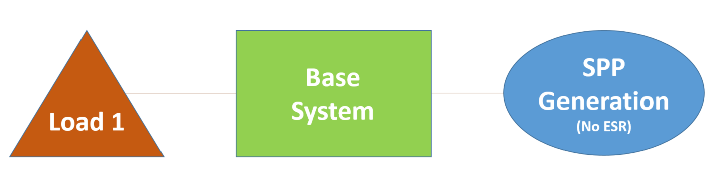
2. Determine the incremental load the SPP system can withstand without exceeding the reliability threshold of one day in ten years by including all ESR and keeping all other generation the same. 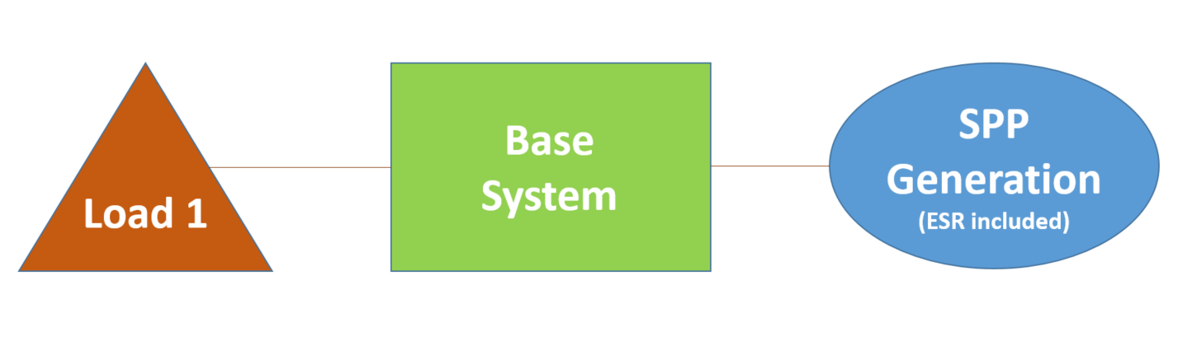
3. Calculate the accredited ELCC value by taking the difference of load required in step one and the load required in step two divided by the amount of analyzed nameplate capacity. $$ELCC Value= \frac{(Load 1-Load 2)}{Nameplate Capacity}$$
4. Repeat Steps 1-3 for each study scenario

## Allocation Process

After the total capacity values for the SPP footprint have been determined for all energy storage scenarios through the ELCC analysis, the data will be plotted using the installed/proposed nameplate generation vs. the ELCC calculated percentage. This will produce a curve that will have an equation that will be utilized for calculating allocation of capacity for each of the tiers. The total penetration of batteries will dictate the flat percentage of accreditation that all batteries will receive based on each Tier, regardless of location of the resource. For example, if the penetration of batteries is 4,000MW for a four hour product then the all batteries would receive approximately 95% accreditation.

Results for each study year will be plotted as ELCC percentage vs studied max as percentage of peak load and averaged together to create an accredited value for each tier.

## ELCC Capacity Allocation

1. **ESR with Four Hour Rating**

Based on the four-hour continuous availability requirement, four-hour batteries would receive accreditation based on the four-hour curve for the battery penetration level of all battery resources on the system at the time of the ELCC assessment.

1. **ESR with Two Hour Rating**

Based on the four-hour continuous availability requirement, two hour batteries would receive accreditation on the four-hour curve based on the penetration level and would receive a maximum 50% accreditation. (For example, a 100MW-hour battery rating would be capable of providing a maximum 50MW of capacity for two continuous hours. However, based on the requirement to be available for four continuous hours, the battery would be capable of providing 25 MW of capacity. The accreditation of the battery would then be determined by using the ELCC four-hour curve for the battery penetration level of all battery resources on the system at the time of the ELCC assessment).

1. **ESR with Six Hour, Eight Hour, or Greater Rating**

Batteries greater than four hours will be treated as four-hour batteries in the study. If the SAWG determines that the minimum duration of ESR should be increased beyond a four-hour minimum, this policy will be re-visited

# Reporting and Deliverables

The ELCC Study scope will be reviewed and approved by the SAWG. The ELCC results will be presented to the SAWG for informational purposes.

1. The value 90% for cycle efficiency was derived by taking the average of Li-ion ESR listed in the following resources: https://www.eesi.org/papers/view/energy-storage-2019 & eia.gov/analysis/studies/electricity/batterystorage/pdf/battery_storage.pdf